Agentic AI vs Generative AI

**Who’s Writing the Script, and Who’s Actually Running the Show?**

As artificial intelligence continues to evolve from a buzzword into a core business capability, two specific types of AI are becoming increasingly important. Generative AI and Agentic AI are both powerful and intelligent, but they serve very different purposes. One creates content and ideas, while the other takes action and makes decisions. One is useful for imagination and storytelling, and the other gets things done without asking twice.

If you have ever used an AI chatbot to generate a marketing draft or watched a system handle customer service without a human stepping in, you have already interacted with both of these AI approaches. To use them responsibly and effectively, it is important to understand what each one does, when to rely on them, and how to avoid the common pitfalls that come with both.

Let’s start with the type of AI that is doing most of the talking.

# What is Generative AI?

Generative AI refers to systems that are built to produce new content. These systems do not simply retrieve facts or search through databases. Instead, they learn from vast quantities of information and then generate new material based on what they have learned. The results can include text, images, code, music, synthetic speech, or even video.

Large language models like GPT-4 or image models like DALL·E are prime examples of this approach. They are trained on enormous amounts of publicly available content from the internet and other sources. When you give them a prompt, they generate a response that mimics human communication in a way that is often impressive and surprisingly nuanced.

Generative AI is especially useful in areas like content creation, marketing, product design, and communication. It can draft reports, generate advertising slogans, create visuals, or summarize long documents in seconds. It gives individuals and teams the ability to scale creativity and output at speeds that were not possible before.

Despite its strengths, this type of AI has some serious weaknesses. Generative models often produce inaccurate or entirely fictional information. These errors are sometimes called hallucinations and are often presented with a level of confidence that makes them easy to believe. The model does not actually know if what it says is true. It simply predicts what comes next based on its training.

This becomes a problem when businesses rely on the output without checking its accuracy. In addition, there are concerns around bias, misinformation, privacy, and even copyright. Since generative AI is trained on vast and often uncontrolled data sources, the content it produces can reflect harmful stereotypes or include traces of protected material. It is also vulnerable to manipulation by users who know how to trick the model into misbehaving.

In short, generative AI is extremely good at sounding smart and creating content. But it requires strong oversight, clear guardrails, and a healthy dose of human review.

# What is Agentic AI?

Agentic AI takes a different approach. These systems are designed not to create content, but to take action. They can observe their environment, make decisions, and execute tasks without constant input from a human operator. In other words, they can act independently based on their understanding of a situation and a set of goals.

Agentic AI is commonly found in applications like robotics, automation, cybersecurity, and autonomous vehicles. It is the kind of system that notices when something changes, decides how to respond, and takes action without waiting for approval.

These AI agents often rely on sensors, logic engines, and planning tools to operate effectively. Some include language capabilities to communicate with users, but their main strength lies in what they do, not what they say.

For example, a cybersecurity agent might scan for threats, block suspicious activity, and adjust firewall rules based on evolving risk. A logistics agent could reroute deliveries in real time if weather or traffic causes delays. In both cases, the AI is not just responding to a prompt. It is working toward a defined goal and adjusting its actions as conditions change.

This ability to operate autonomously brings major benefits. Agentic AI increases efficiency, reduces response times, and handles complexity that would overwhelm human operators. It is especially valuable in environments where speed, accuracy, and consistency matter.

However, this independence also creates new challenges. When an AI system makes decisions that affect people or critical infrastructure, transparency becomes essential. It must be possible to understand how and why a decision was made. Otherwise, trust quickly erodes.

Like generative AI, agentic systems are susceptible to bias, unintended consequences, and security threats. In addition, questions of accountability become more serious. If an autonomous system causes harm, who is responsible? These are questions that every organization must address before putting agentic systems into production.

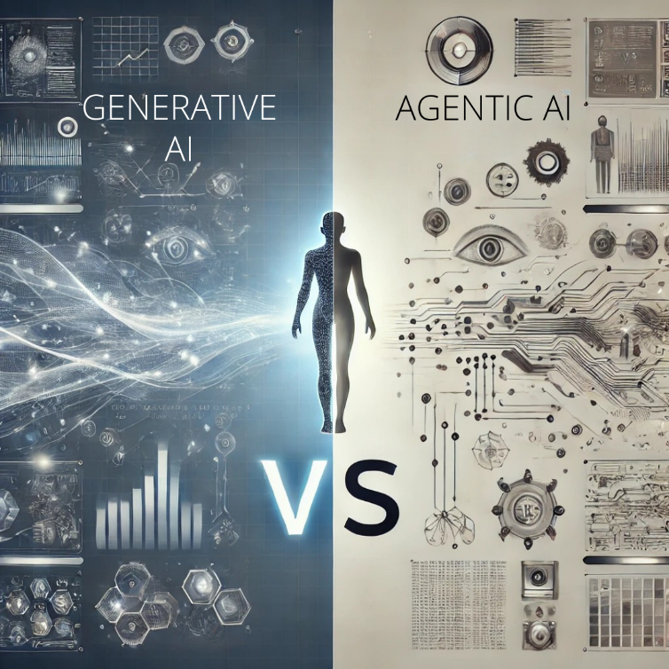

# What Makes Them Different?

The primary difference between generative AI and agentic AI is their function. Generative AI is focused on content. It produces things like articles, images, or summaries in response to input. It is designed to be expressive and creative, but it does not act on its own.

Agentic AI is focused on action. It is built to accomplish tasks, often without waiting for instructions. It uses its understanding of the environment and its objectives to make decisions and follow through with actions.

You can think of generative AI as the writer and agentic AI as the operations manager. One comes up with ideas, whereas the other gets things done.

|  |  |  |
| --- | --- | --- |
| Attribute | Generative AI | Agentic AI |
| Primary Role | Content creation | Task execution |
| Autonomy | Responds to prompts | Operates independently toward a goal |
| Use Cases | Writing, art, summarizing, ideation | Workflow automation, task management, robotics |
| Interaction Style | User-driven | Environment or data driven |
| Key Risks | Hallucination, misinformation, bias | Unintended outcomes, traceability gaps |

# When to Use Each

Generative AI is a strong fit for tasks that involve communication, creativity, or knowledge synthesis. If you need to create a marketing message, summarize a report, brainstorm product names, or generate a social media calendar, generative AI is your tool of choice.

Agentic AI is more appropriate when decisions need to be made or actions need to be taken, especially in environments where time and precision are critical. If your goal is to automate a workflow, detect and respond to threats, or control physical systems like robots or autonomous vehicles, then agentic AI is the better fit.

Many enterprise applications benefit from combining the two. For example, a digital assistant may rely on a generative model to craft a response in plain language, while using an agentic layer to decide when to respond, how to escalate, or what action to take based on user behavior.

# How They Work Together

These two types of AI are not in competition. In fact, the most powerful AI systems today often blend the strengths of both.

An agentic AI might include a generative module that helps it communicate clearly. A generative system might work under the control of an agentic layer that assigns tasks and reviews outcomes. Together, they form intelligent systems that can not only understand and create but also plan and act.

The key is in knowing how to govern them.

# The Importance of Governance

Whether you are using generative AI, agentic AI, or a hybrid of both, strong governance is essential. These systems are not just tools. They are decision makers and communicators, and they must be managed accordingly.

Generative AI requires careful content review, quality assurance, and bias detection. Agentic AI needs clear boundaries, escalation protocols, and traceability of decisions. Both must comply with ethical standards, privacy laws, and security expectations.

Frameworks such as the NIST AI Risk Management Framework, the EU AI Act, and ISO 42001 provide important structure and best practices. But ultimately, every organization must define its own policies based on risk appetite, business goals, and stakeholder expectations.

AI is not just another technology to plug in and forget. It is an evolving capability that requires continuous oversight, responsible design, and clear accountability.

# Best Practices for Putting These Systems to Work

Here are five strategies to help you use generative and agentic AI effectively and responsibly:

1. **Start with clear goals**: Define what you want the AI to do. Output and action require different approaches.
2. **Choose the right tools for the job**: Do not force generative AI to behave like an agent, or vice versa. Use each where it performs best.
3. **Monitor performance**: Use metrics and feedback loops to track how your AI is performing. Look for accuracy, reliability, and user impact.
4. **Establish governance early**: Apply ethical standards, create human review checkpoints, and ensure transparency in decisions.
5. **Build for scale and safety**: As you grow your AI capabilities, invest in systems that support oversight, version control, and rollback in case of errors.

# Final Thoughts

Generative AI is here to help you think faster and create more. Agentic AI is here to help you act smarter and work more efficiently. They are not competitors. They are complementary forces in the evolution of intelligent systems.

By understanding how each one works and what each one offers, you can build AI solutions that do more than just talk. They can listen, learn, and lead. And if designed responsibly, they can help your organization move faster, think bigger, and reduce risk while staying in control.

**Ready to align your AI strategy with responsible innovation?** Explore our governance toolkit or connect with our team for a custom AI roadmap.